**WEEK 7**

**Zayd Ahmed**

**1BM21CS254**

**26-07-2023**

**Q:** Use bankers algo given here to check if the following state is safe/unsafe:

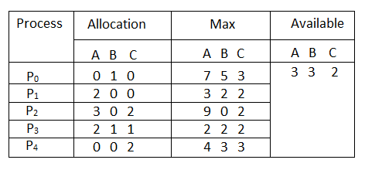

#include <stdio.h>

int main()

{

int n, m, i, j, k;

printf("enter the number of processes\n");

scanf("%d", &n);

printf("enter the number of resources\n");

scanf("%d", &m);

int alloc[n][m], max[n][m];

printf("enter allocation matrix\n");

for (i = 0; i < n; i++)

{

for (j = 0; j < m; j++)

{

scanf("%d", &alloc[i][j]);

}

}

printf("enter the max matrix");

for (i = 0; i < n; i++)

{

for (j = 0; j < m; j++)

{

scanf("%d", &max[i][j]);

}

}

int avail[m];

printf("enter the available resources\n");

for (i = 0; i < m; i++)

{

scanf("%d", &avail[i]);

}

int f[n], ans[n], ind = 0;

for (k = 0; k < n; k++)

{

f[k] = 0;

}

int need[n][m];

for (i = 0; i < n; i++)

{

for (j = 0; j < m; j++)

need[i][j] = max[i][j] - alloc[i][j];

}

int y = 0;

for (k = 0; k < 5; k++)

{

for (i = 0; i < n; i++)

{

if (f[i] == 0)

{

int flag = 0;

for (j = 0; j < m; j++)

{

if (need[i][j] > avail[j])

{

flag = 1;

break;

}

}

if (flag == 0)

{

ans[ind++] = i;

for (y = 0; y < m; y++)

avail[y] += alloc[i][y];

f[i] = 1;

}

}

}

}

int flag = 1;

for (int i = 0; i < n; i++)

{

if (f[i] == 0)

{

flag = 0;

printf("The following system is not safe");

break;

}

}

if (flag == 1)

{

printf("Following is the SAFE Sequence\n");

for (i = 0; i < n - 1; i++)

printf(" P%d ->", ans[i]);

printf(" P%d", ans[n - 1]);

}

return (0);

}

**OUTPUT:**

